SOC FUNDAMENTALS WALKTHROUGH
Objectives of SOC Fundamentals module:
- Building a baseline for SOC (Security Operations Center).
- Detection and response in SOC.
- The role of People, Processes, and Technology.
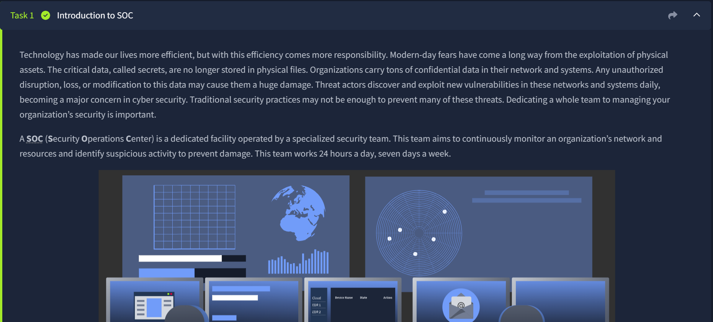
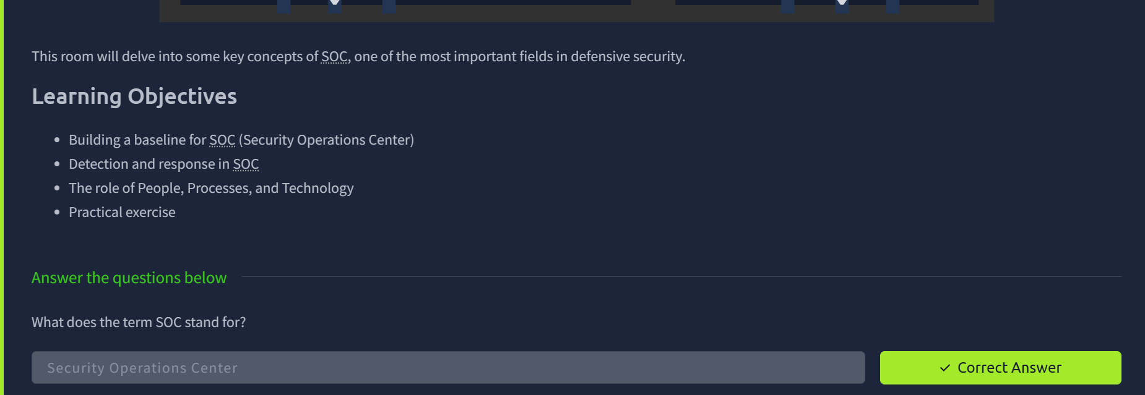
Introduction to SOC Questions
Q: What does the term SOC stand for?
Security Operations Center – A dedicated facility operated by a specialized security team.

Task 2: Purpose and Components
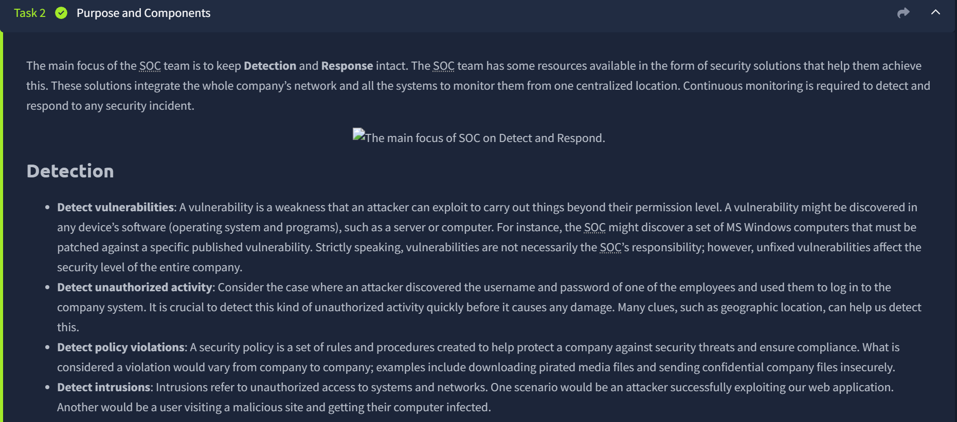
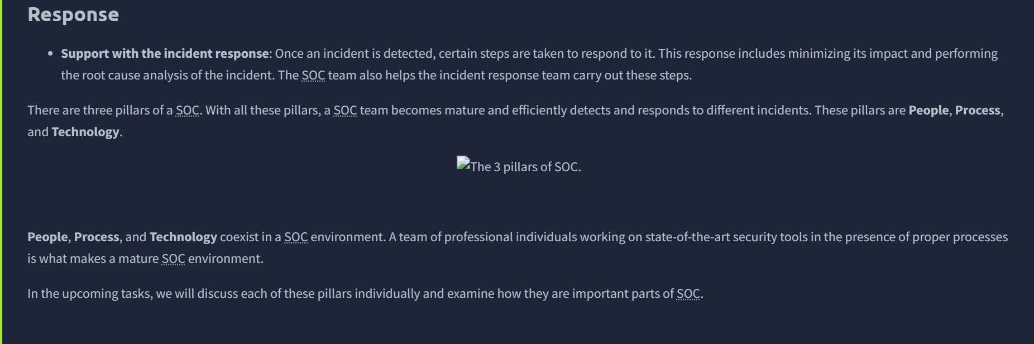
Questions
Q: The SOC team discovers an unauthorized user is trying to log in to an account. Which capability of SOC is this? Detection.
Q: What are the three pillars of a SOC? People, Process, and Technology.
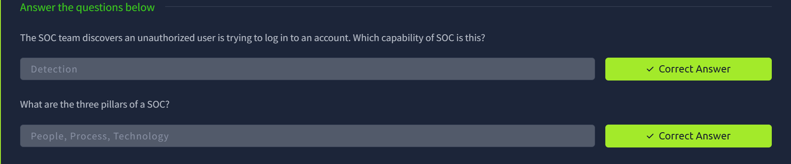

Task 3 People
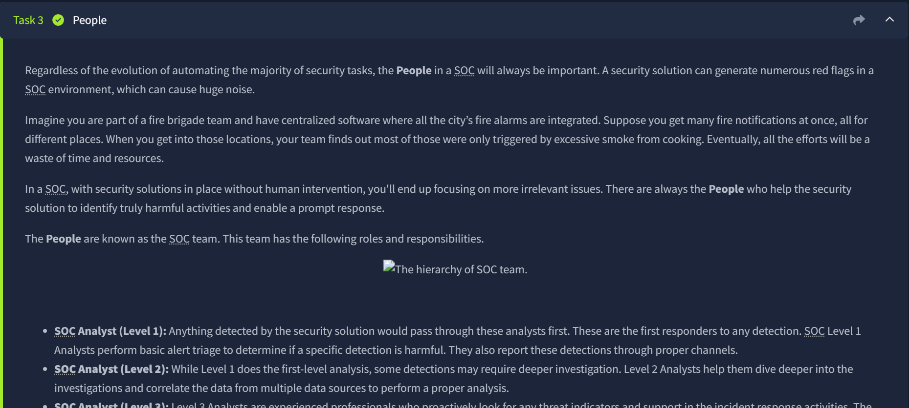
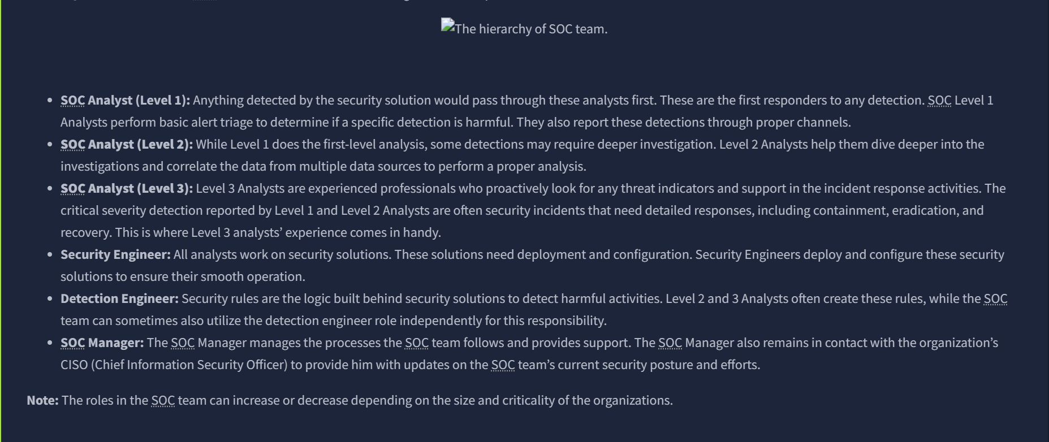
Questions
Q: Alert triage and reporting is the responsibility of? SOC Analyst (Level 1).
SOC Level 1 Analysts perform basic alert triage to determine if a specific detection is harmful.
Q: Which role in the SOC team allows you to work dedicatedly on establishing rules for alerting security solutions? Detection Engineer.
The SOC team can sometimes also utilize the detection engineer role independently for the responsibility of building security rules.
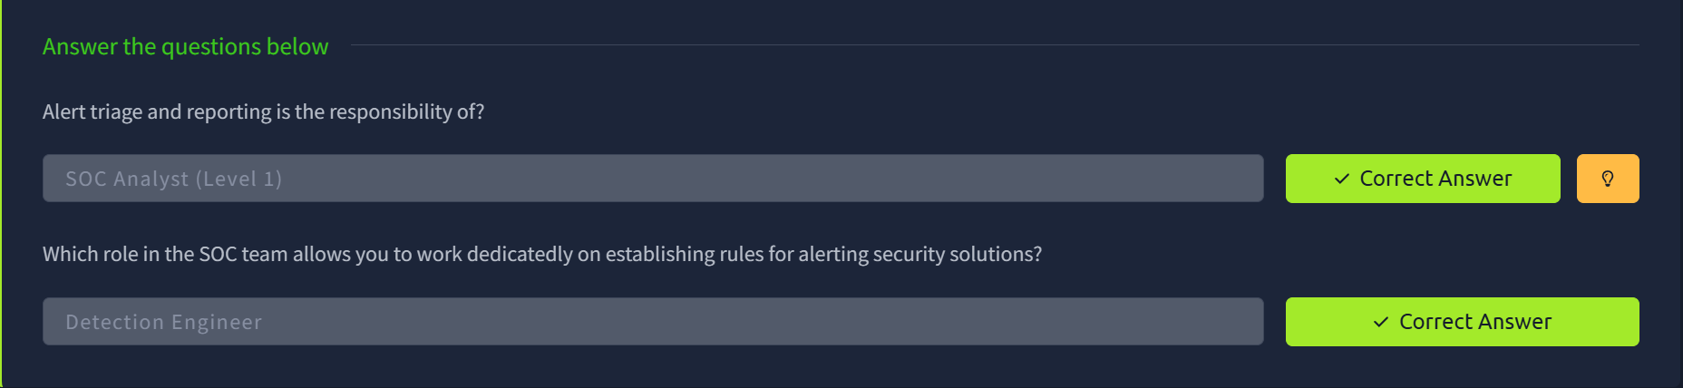
Task 4: Process
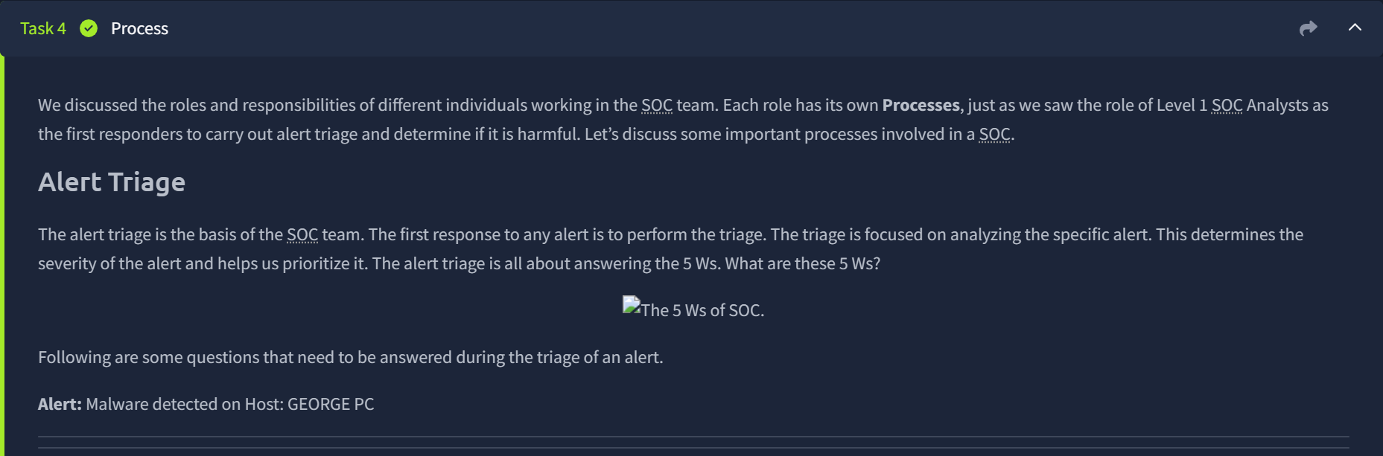
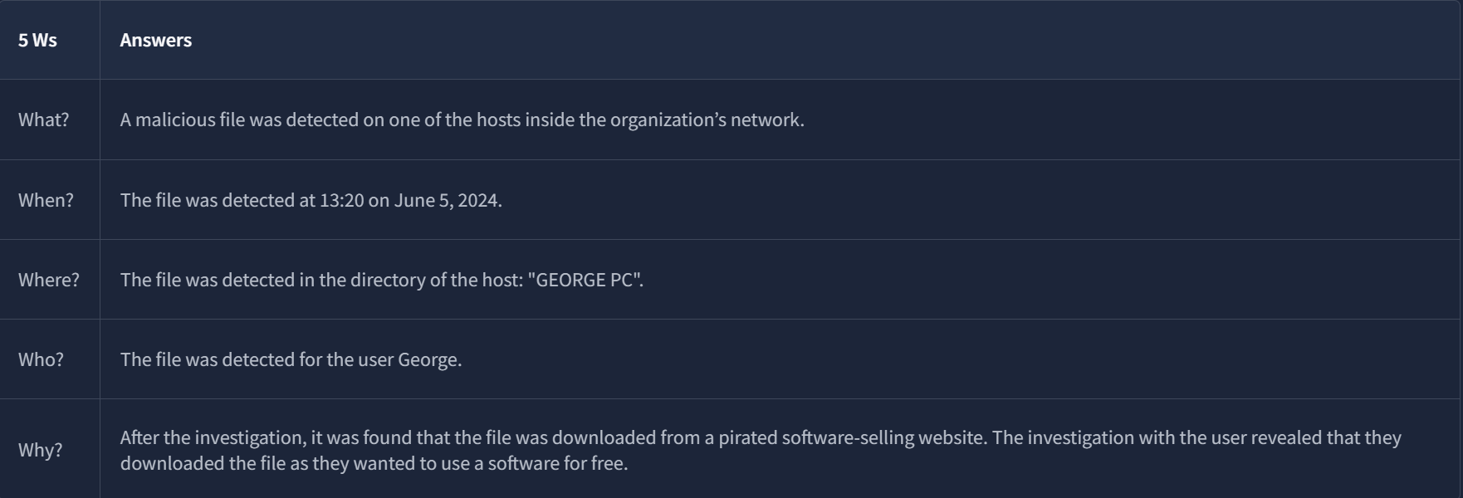
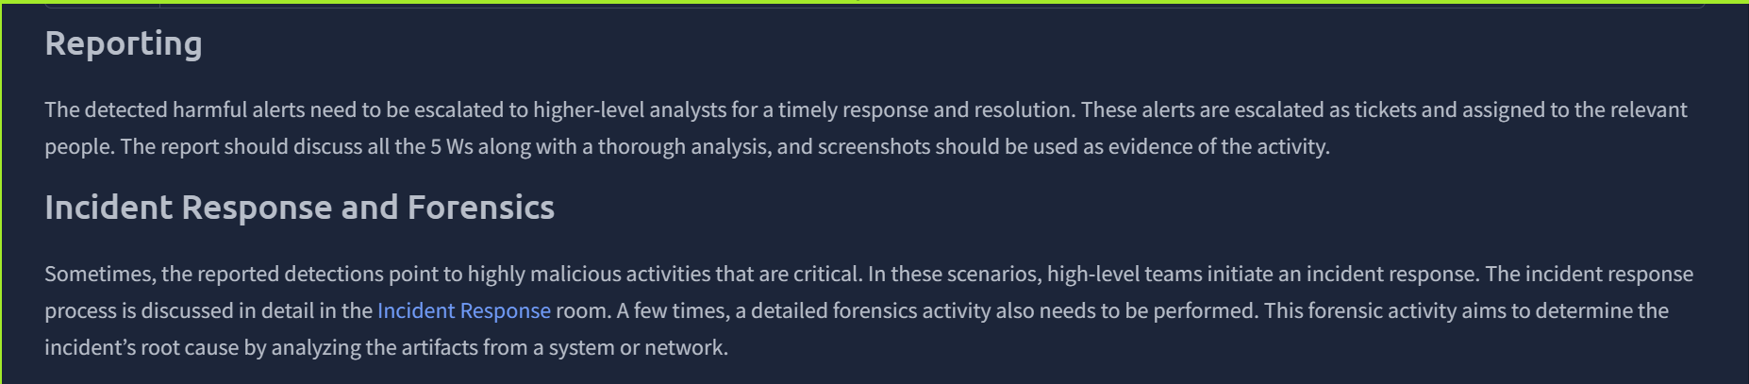
Task 4 Process:
Q: At the end of the investigation, the SOC team found that John had attempted to steal the system's data. Which 'W' from the 5 Ws does this answer? Who
Q: The SOC team detected a large amount of data exfiltration. Which 'W' from the 5 Ws does this answer? What
What? The data.
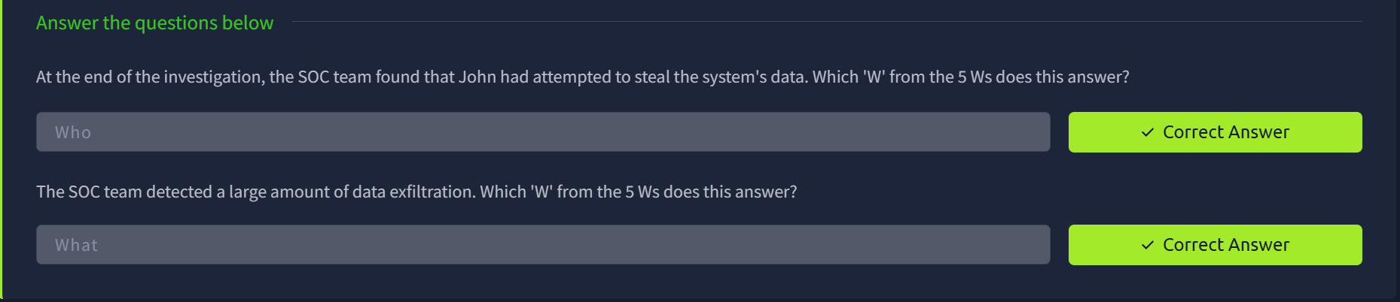

Task 5 Technology
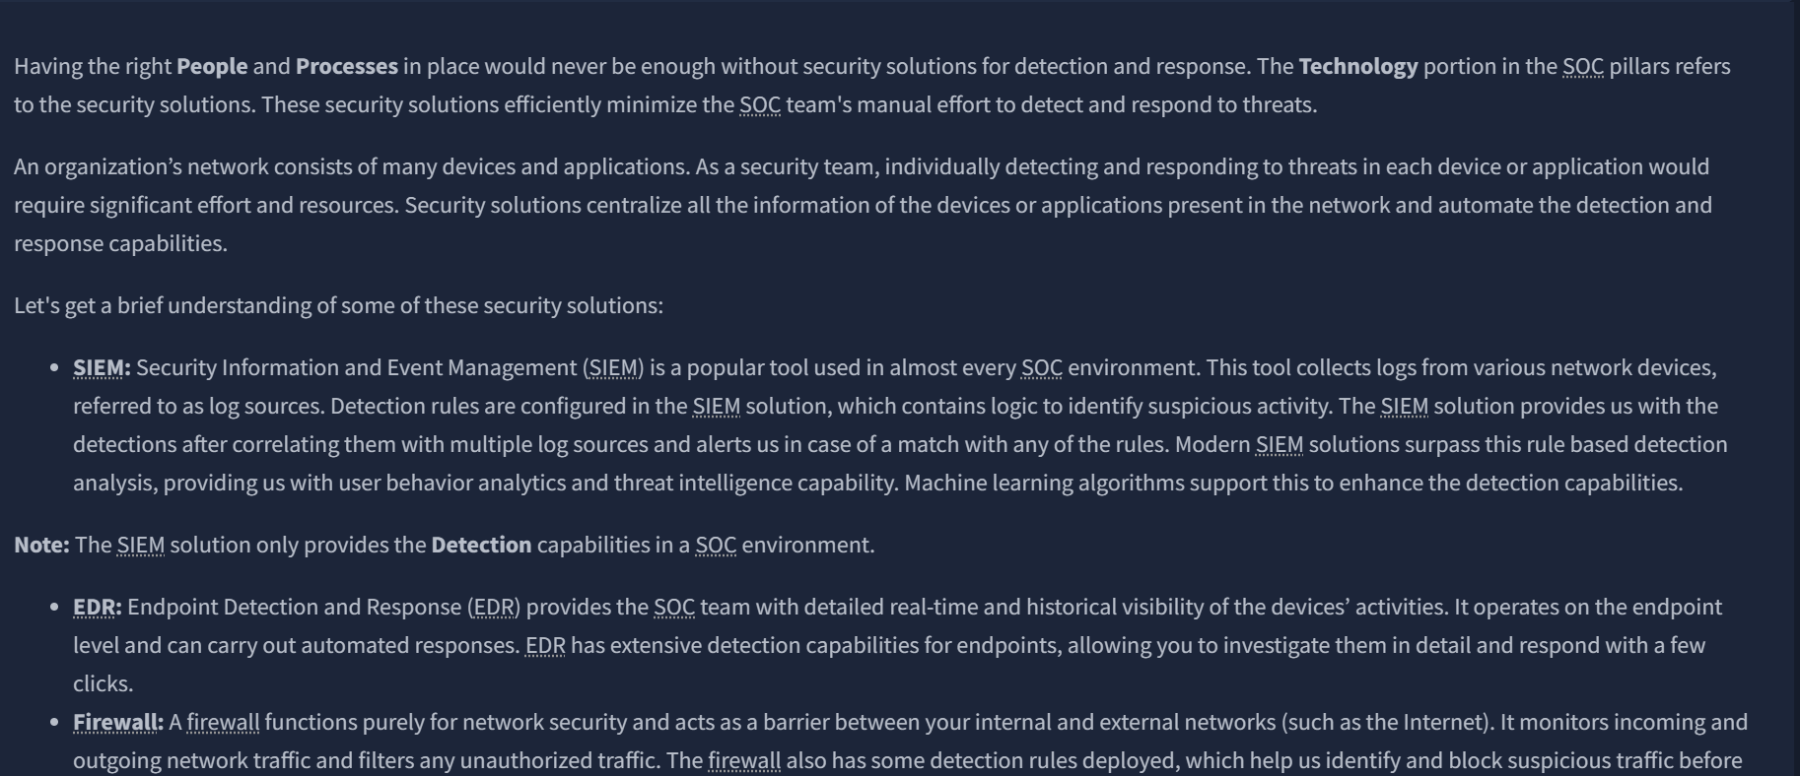
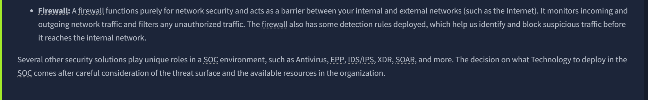
Questions
Q: Which security solution monitors the incoming and outgoing traffic of the network? Firewall.
A firewall functions purely for network security and acts as a barrier between your internal and external networks such as the Internet. It monitors incoming and outgoing network traffic and filters any unauthorized traffic.
Q: Do SIEM solutions primarily focus on detecting and alerting about security incidents? (yea/nay) Yea.
The SIEM solution provides us with the detections after correlating them with multiple log sources and alerts us in case of a match with any of the rules.

Task 6: Practical Exercise of SOC
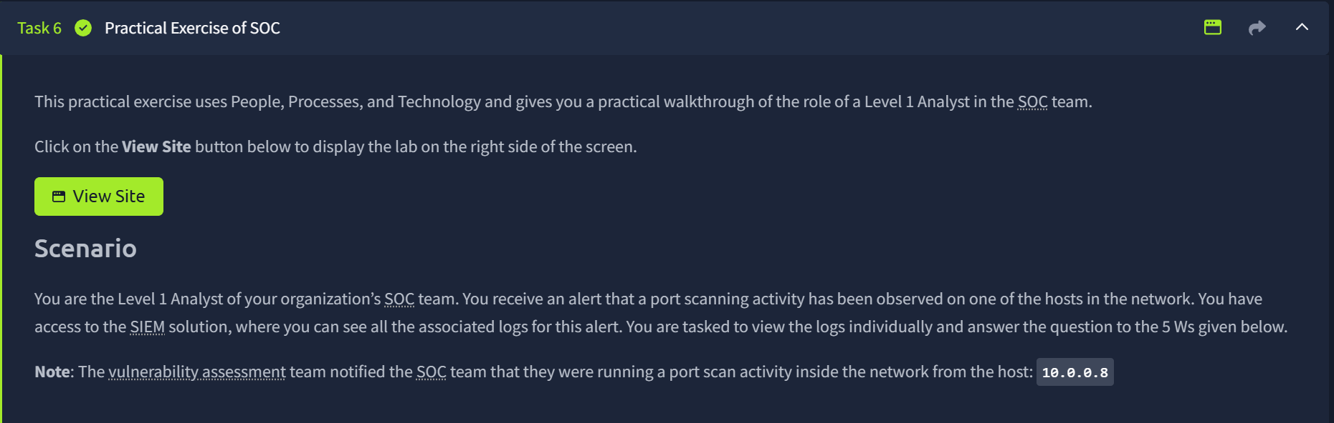
The “View Site” button page
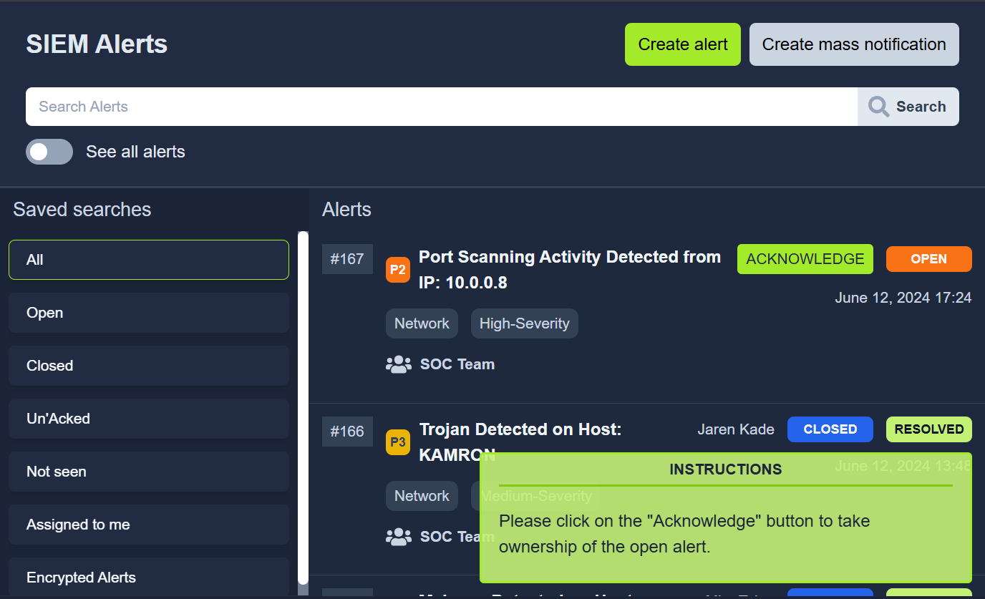
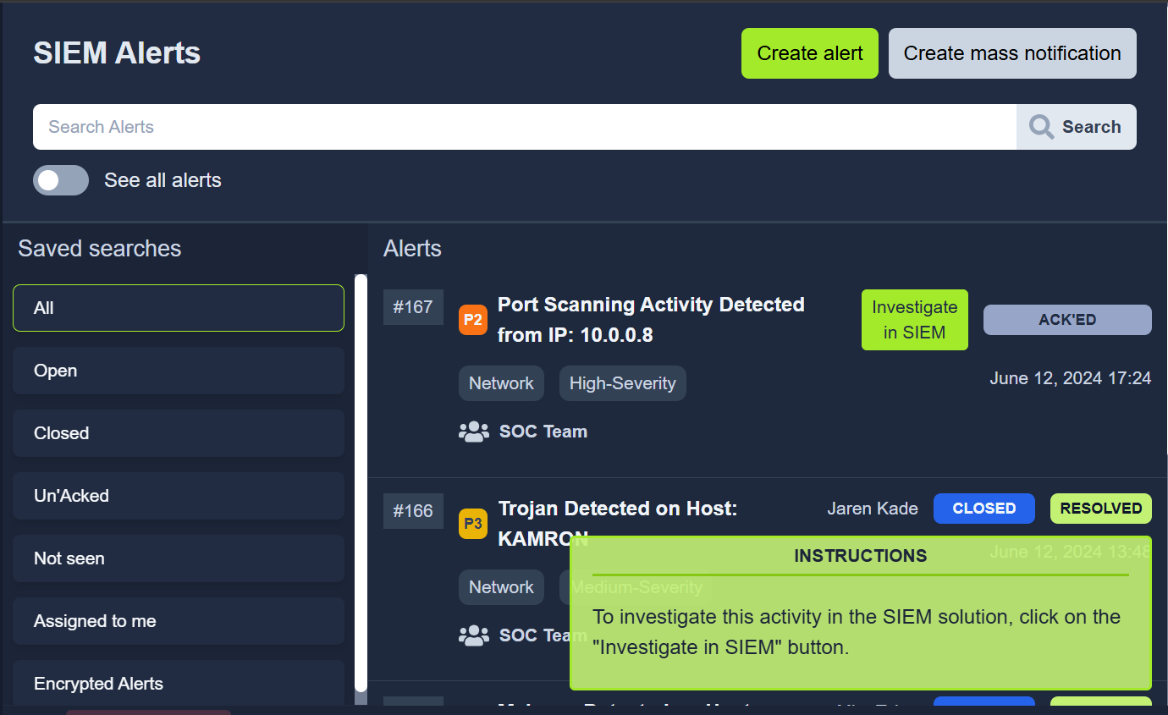
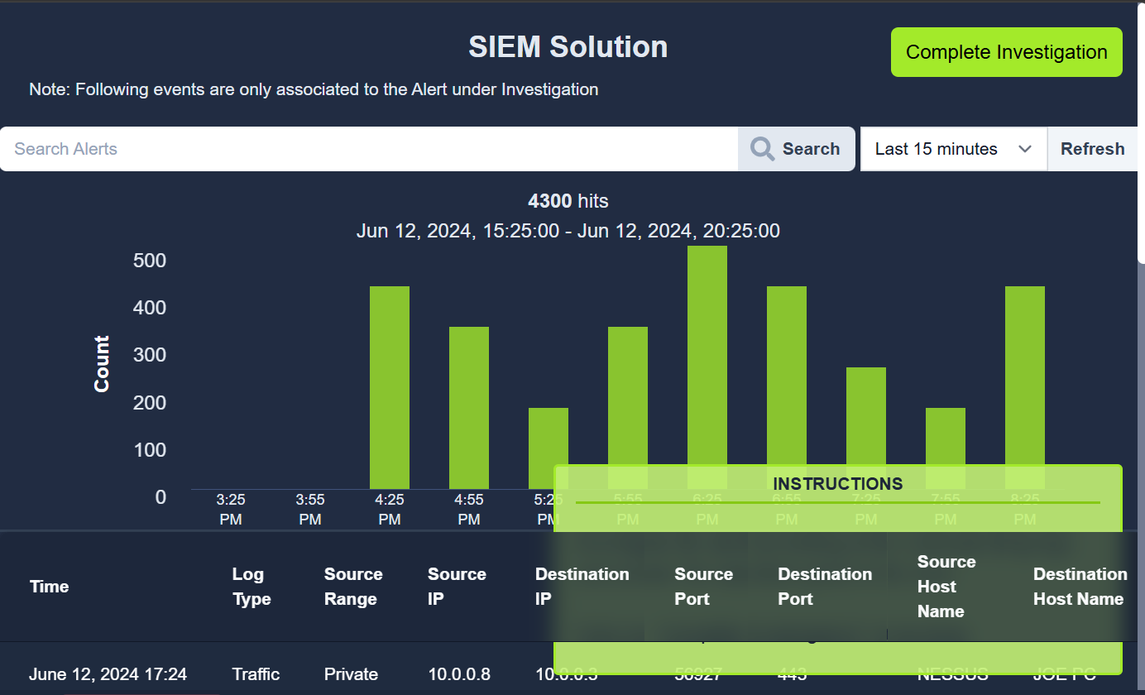
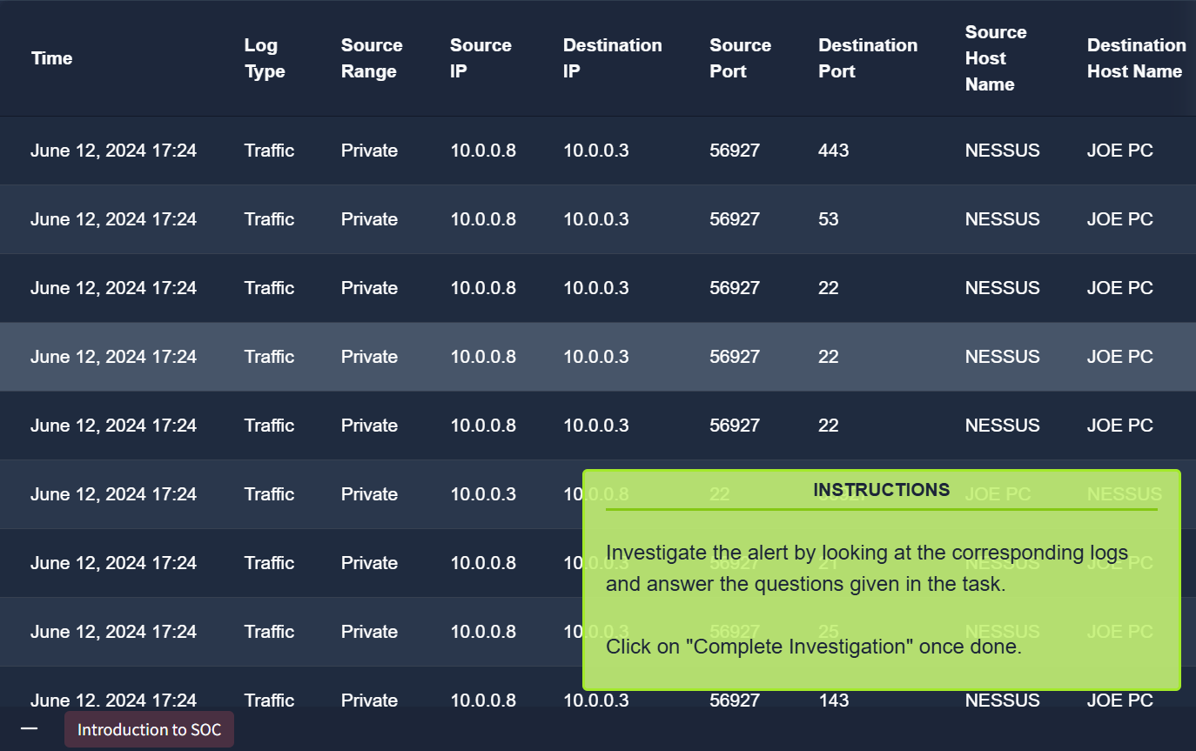
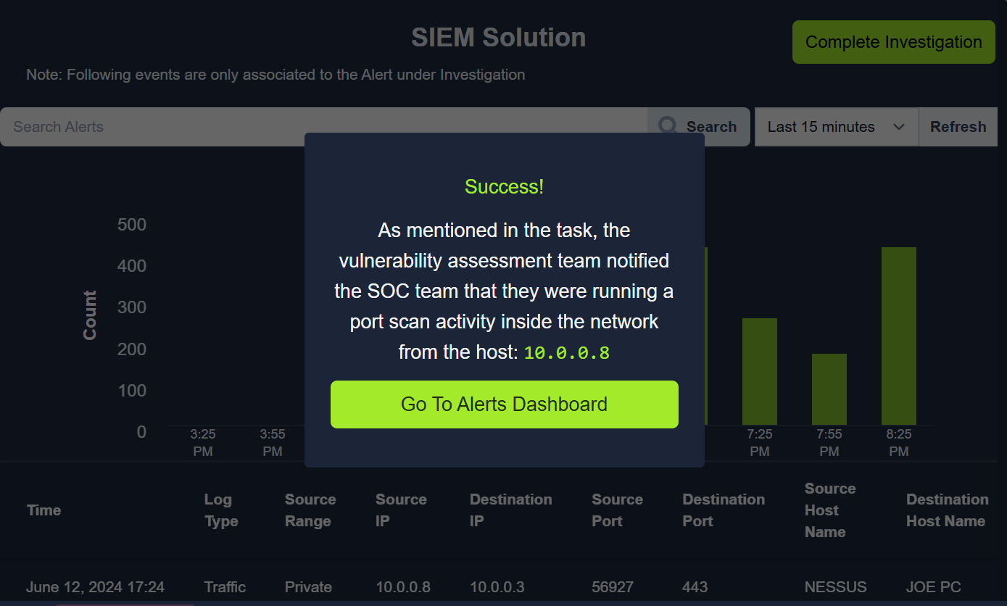
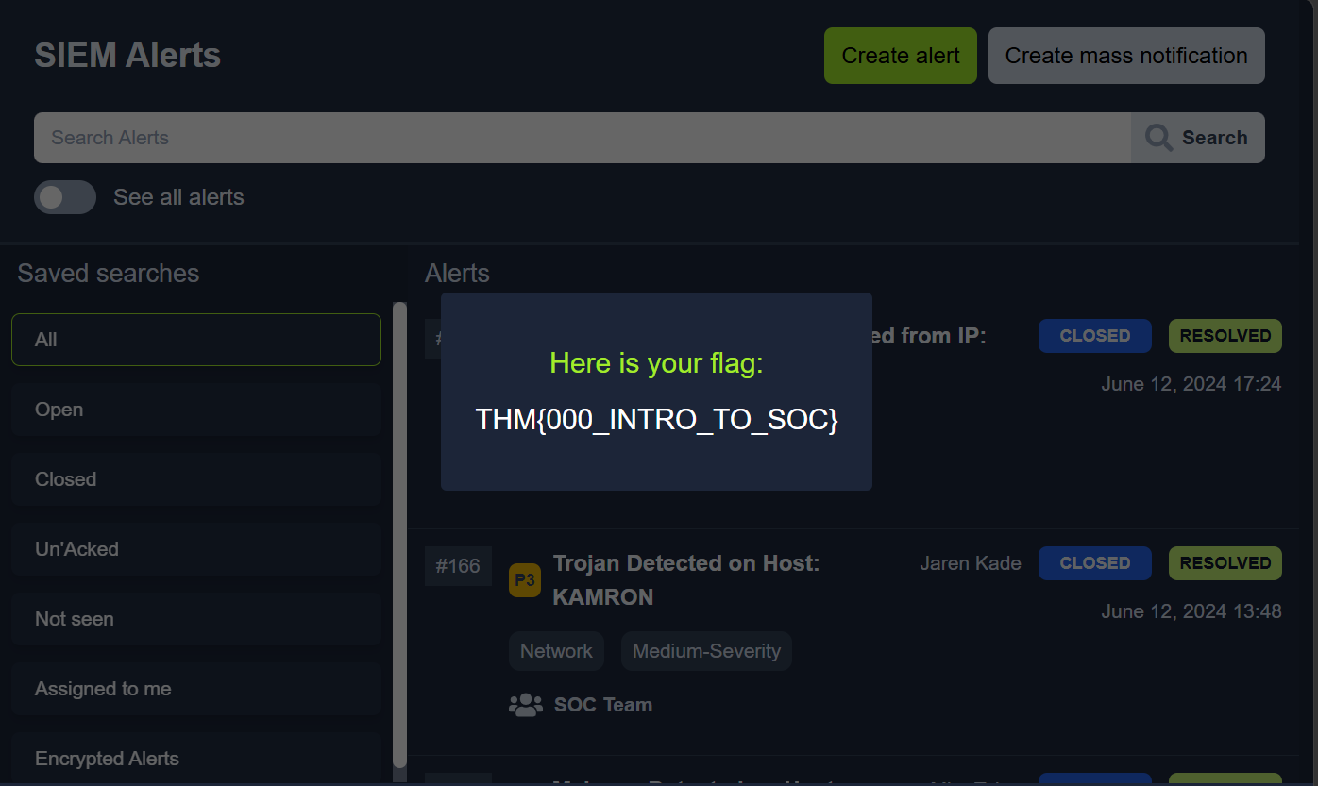
Flag: THM{000_INTRO_TO_SOC}.
Questions
Q: What: Activity that triggered the alert? Port Scan
“You receive an alert that a port scanning activity has been observed on one of the hosts in the network.”
Q: When: Time of the activity? June 12, 2024 17:24
Q: Where: Destination host IP? 10.0.0.3
Q: Who: Source host name? Nessus
Q: Why: Reason for the activity? Intended/Malicious? Intended.
Q: Additional Investigation Notes: Has any response been sent back to the port scanner IP? (yea/nay) yea.
Q: What is the flag found after closing the alert? THM{000_INTRO_TO_SOC}.
Task 7: Conclusion
